

Scrum Master
Ms. Merin Chacko
Assistant Professor
Department of Computer Applications
Nurturenest
20INMCA509 - Mini Project 2
Ashlymol Thomas
AJC20MCA-I020
INMCA2020-25 S9
https://github.com/IntAshly/MiniProject_2.git
ashlymolthomas2025@mca.ajce.in

UML DIAGRAMS
Use Case Diagram
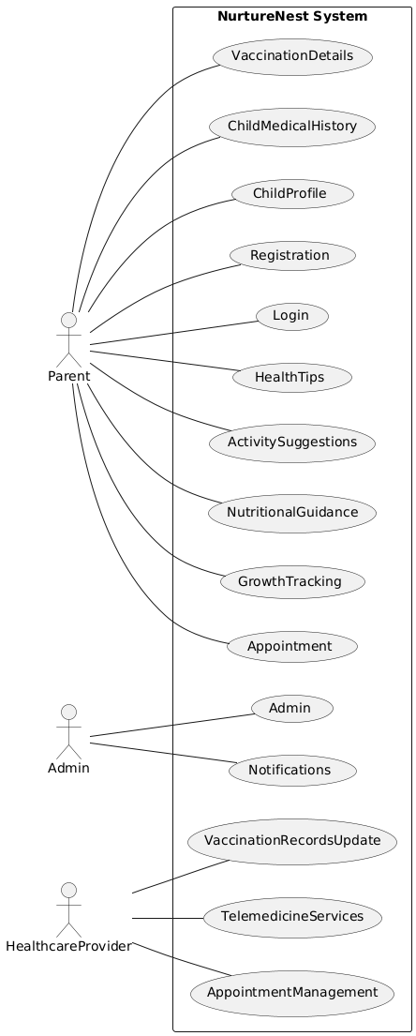

Sequence Diagram

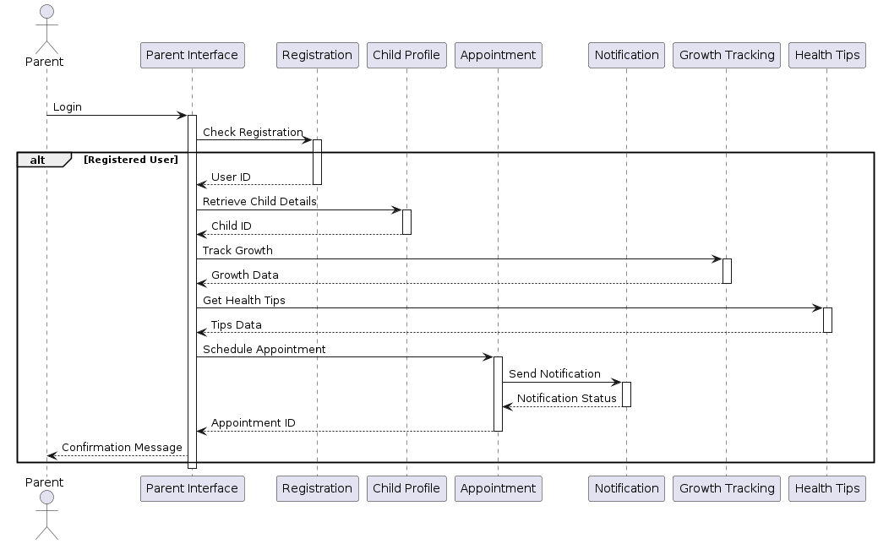

Class Diagram

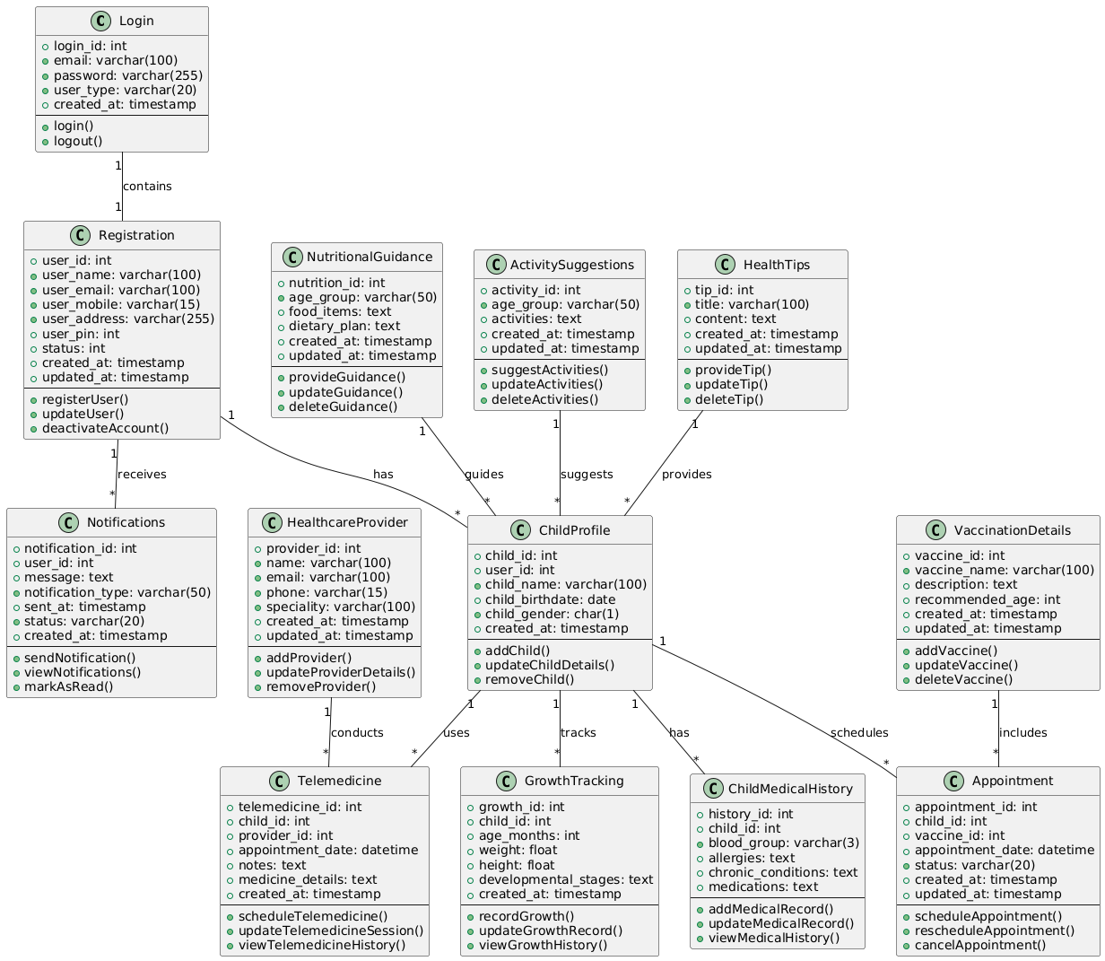

Object Diagram

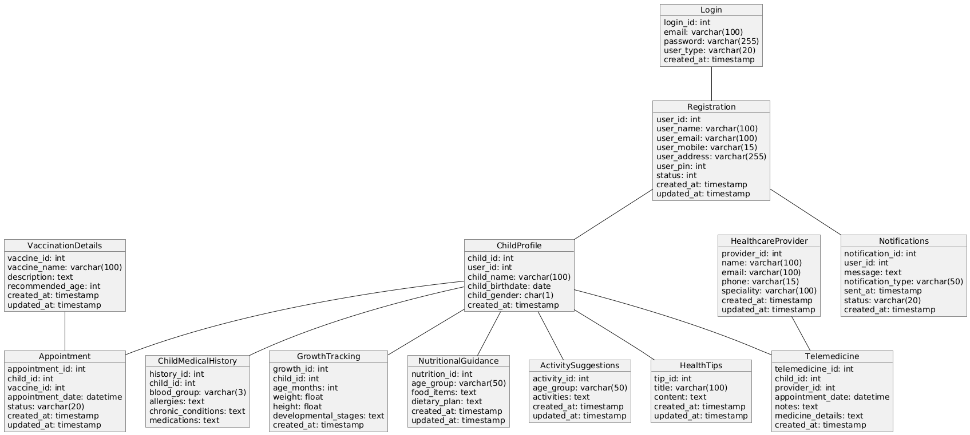

Activity Diagram
